# Task 2 :

1. Write Python application which creates CSV file with the given sample data.

2. Use Pandas framework.

3. Set up as containerized solution.

# Requirements:

* Python 3.7 to be installed
* Pandas framework
* Using command prompt, PowerShell or any IDE to test the python logic.
* docker to execute the docker file.

# Logic to implement:

MyRow - initialise and increment by 1

MyString - initialise and concatenate alphabets

MyDate - initialise and increment by a day

Use pandas to push the data into CSV and write docker file for containerization.

# Logic:

# importing necessary libraries

import pandas as pd

import datetime

from string import ascii_lowercase

# creating the lists

MyRow = []

for i in range(1, 21):

MyRow.append(i)

MyString = []

for i in range(1, 21):

MyString.append("".join(ascii_lowercase[:i]))

MyDate = []

start = datetime.date(2022,1,1)

while start <= datetime.date(2022,1,20):

MyDate.append(datetime.datetime.strftime(start,'%Y-%m-%d'))

start += datetime.timedelta(days=1)

# dictionary of lists

dict = {'MyRow': MyRow, 'MyString': MyString, 'MyDate': MyDate}

df = pd.DataFrame(dict)

# saving the dataframe

df.to_csv('File.csv', header=True, index=False)

# added

output = pd.read_csv('File.csv')

print(output)

------------------------------- # end of logic # -----------------------------------------

Printing of result:

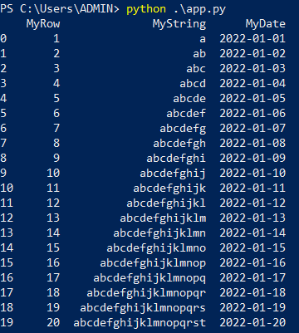

CSV file gets created and saved on the local desktop:

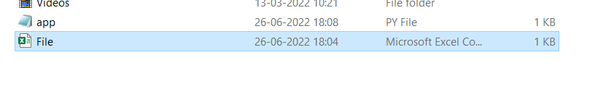

Redhat Linux:

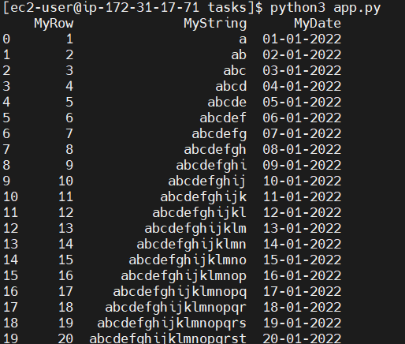

I am taking docker here to make containerised solution.

1. write docker file taking app.py as an application

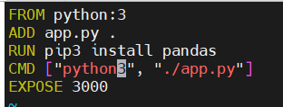

2. build docker image using docker file

docker build -t gouri7676/mypythonimage . – creation of image

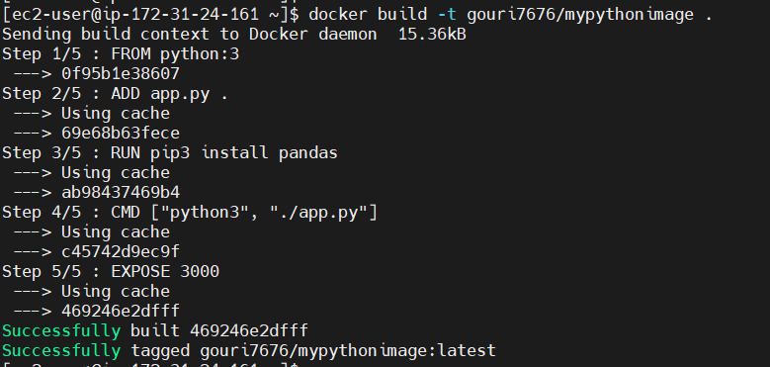

3. Pushing the image to Docker Hub

docker push gouri7676/mypythonimage:latest – pushing to docker hub

4. Containerising python application

Docker run -d -p 8080:3000 gouri7676/mypythonimage:latest

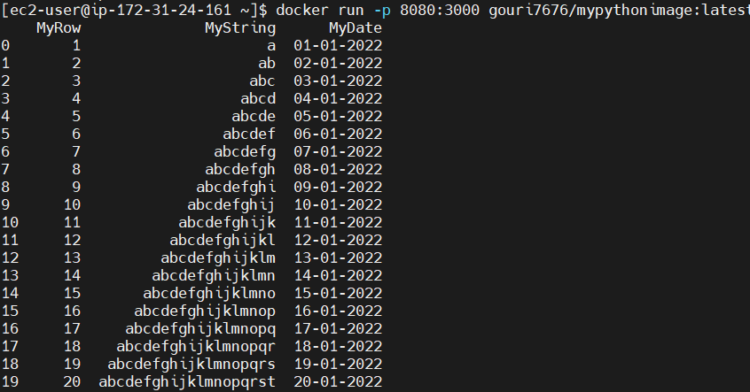

-----------------------------------------------------------------------------------------------------------

Notes :

In Python, string ascii_lowercase will give the lowercase letters ‘abcdefghijklmnopqrstuvwxyz’.

Timedelta can be used for calculating differences in dates and also can be used for date manipulations in Python.

# import string library function

import string

# Storing the value in variable result

result = string.ascii_lowercase

# Printing the value

print(result)

Printing of result:

